MARKING KEY

Sample examination

Stage 3

Physics
2008/18613

PHYSICS
Section one: Short answer

Question 1
Spectra
Description | Mark
A torch and B laser | 1
laser light is monochromatic ie one frequency only unlike a incandescent filament | 1

Question 2
Gravity on Everest
Description | Mark
A | 1
Explanation can be verbal and/or mathematical, e.g.  g at any point depends on the square of the distance from that point to the centre of the earth (g is proportional to 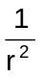). | 1
The height of Mt Everest (about 9000 m) is very much less than the radius of the Earth. The two distances are about 6 409 000 m and 6 400 000 m, and so g will be not very different from what it is at sea level. (g _{Everest} = 99.7% g _{sea level}) | 1

Question 3
Quasars
Description | Mark
Large redshift means that the object is receding from us at high speed | 1
Hubble’s law suggests that high recession rates mean great distances | 1

Question 4
Screwdrivers
Description | Mark
Q is better | 1
there is a greater torque for the same applied force as torque is proportional to the radius of the handle τ = r x F | 1

Question 5(a)
Orbital velocity
Description | Mark
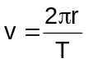 | 1
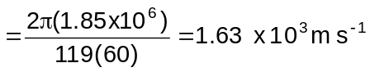 | 1

Question 5(b)
Moon mass
Description | Mark
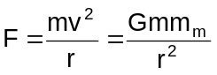 | 1
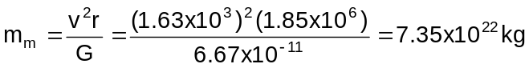 | 1

Question 6(a)
Magnet
Description | Mark
N  S | 1

Question 6(b)
Magnetic field
Description | Mark
N  S | 1

Question 7(a)
Enclose magnetic flux
Description | Mark
Plane of the rim must be vertical | 1
and in the east-west direction | 1

Question 7(b)
Estimate magnetic flux
Description | Mark
Reasonable estimate of radius of wheel eg 0.3 m | 1
Φ = B A | 1
= 55 × 10⁻⁶ × π × 0.3² Wb  = 2 x 10⁻⁵ Wb | 1

Question 8
Waves in a pulse
Description | Mark
frequency is number of pulses or vibrations each second | 1
substitute time to be 0.10 μs, so number is [3.3 x 10⁹ ] x 0.1 x 10⁻⁶ = 330 | 1

Question 9(a)
Induced current
Description | Mark
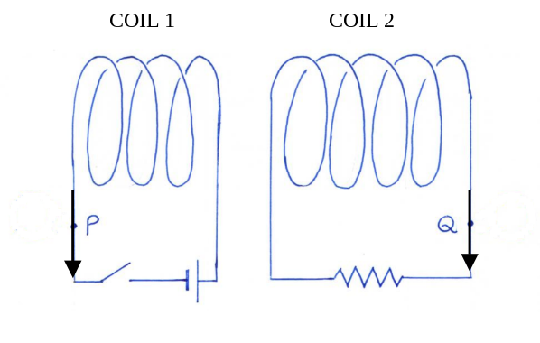  Current in coil 1 1 mark  Current in coil 2 1 mark | 2

Question 9(b)
Current change
Description | Mark
It decreases to zero | 1

Question 10(a)
Directions of forces
Description | Mark
1 mark for each correct arrow | 2

Question 10(b)
Magnitudes of forces
Description | Mark
1.2m 0.8 m 2.0 m  D  W  C  P  Board is in equilibrium therefore Σ CWM = Σ ACWM  Taking moments about P:  W (0.8) + D (2.8) = C (1.2)  (120) (9.8) (0.8) + (62.5) (9.8) (2.8) = (C (1.2)  C = 2.21 x10⁴ N | 1
Σ F_{up} = Σ F_{down}  P = C + W + D  = 2.21 x10⁴ + 120 (9.8) + 62.5 (9.8)  = 4.00 x10³ N | 1

Question 11
Particle motion in magnetic field
Description | Mark
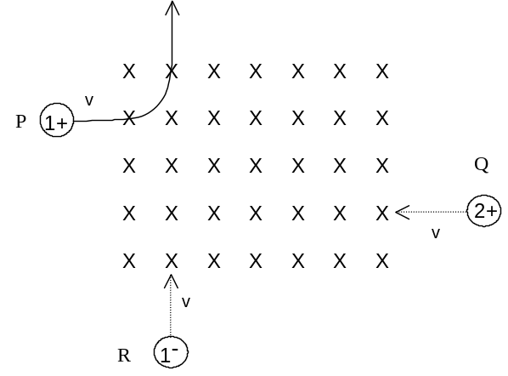  Directions of paths of Q, R = 1 each = 2 marks  Relative curvature = 1 mark | 3

Question 12
Free body diagram and force calculation
Description | Mark
T  T  37°  37°  T_{leg} | 1
For equilibrium: ΣF = 0  ∴ ΣF_{left} = ΣF_{right} | 1
T_{leg} = 2 T_{rope} cos37°  = 2 x 20 x 9.8 cos 37°  = 313 N (=310 N) | 1

Question 13
Gravitational null point
Description | Mark
  g_{M} g_{E}  Moon  Earth  X  d  (R – d) | 1
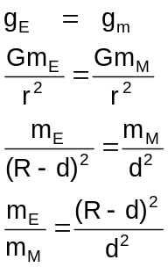 | 1
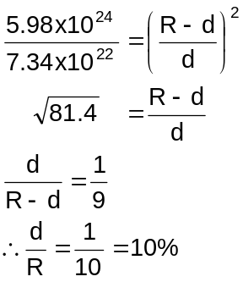 | 1

Question 14
Cancelling electric and magnetic fields
Description | Mark
Electric force given by 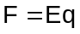 and magnetic force given by 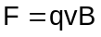 | 1
In order to cancel these must be numerically equal i.e. 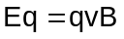 | 1
Hence 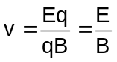 | 1

Question 15
Evidence for neutrinos
Description | Mark
To conserve momentum something must recoil approximately as shown  Track of recoiling  nucleus  Track of recoiling beta particle  Path of unknown particle | 1
This particle does not produce visible tracks so is unlikely to be charged or to have a mass comparable to an electron mass. | 1

Section two: Problem-solving

Question 16(a)
Fundamental and harmonic
Description | Mark
Fundamental | 1
Next possible harmonic | 1
Chimney is open at one end and closed at the other | 1
Open end is a displacement antinode, closed end is a displacement node | 1

Question 16(b)
Length of chimney
Description | Mark
Assume that speed of sound in air is 342 m s⁻¹ | 1
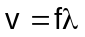 | 1
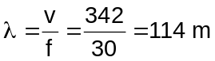 | 1
Open pipe so length= 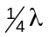=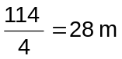 | 1

Question 17(a)(i)
Electron transitions
Description | Mark
Completed all 6 transitions to high degree of accuracy or | 2
Has at least three transitions correctly identified, correct arrow direction | 1
maximum | 2

Question 17(a)(ii)
Electron transition calculation
Description | Mark
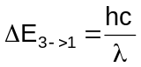 | 1
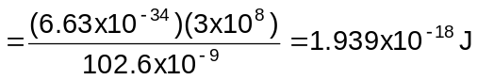 | 1

Question 17(b)(i)
Phenomenon
Description | Mark
Fluorescence | 1

Question 17(b)(ii)
Occurrence
Description | Mark
Atom excited by UV light to a higher energy level | 1
Electrons drop to the ground state in a series of transitions. | 1
At least one of these transitions emits coloured light. | 1

Question 17(b)(iii)
Colour of rabbit
Description | Mark
Peak wavelength of emitted light is about 510 nm. | 1
This corresponds to green light—from spectrum chart at beginning of question 17 | 1

Question 18(a)
Slip rings
Description | Mark
Enables alternating current to be withdrawn from the generator. Maintains constant contact between a particular side of the coil and a given terminal for the external circuit. [Students should indicate this on the diagram.] | 1

Question 18(b)(i)
Graph of emf
Description | Mark
sinusoidal output | 1
Period shown correctly | 1

Question 18(b)(ii)
Graph of new emf
Description | Mark
Voltage is doubled | 1
Period is halved | 1

Question 18(c)(i)
Emf calculation
Description | Mark
3000 rpm = 50 Hz | 1
Using ‘quarter turn’ method A = 0.14 x 0.09 = 0.0126m² and t = 0.005 s | 1
 | 1

Question 18(c)(ii)
Maximum or average
Description | Mark
This is an ‘average’ voltage. (student’s statement must agree with the method used)  [Maximum voltage would be given by NAB(2πf)] | 1
OR
(Students can also calculate rms value given by 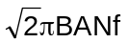) | 1

Question 18(d)
Ways to increase emf: any two of
Description | Mark
Number of turns can be increased, increasing the length of the wire in the coil | 2
Magnetic field can be increased, greater magnetic fields produce greater induced emfs | 2
Area of coil can be increased, greater area means the flux change is greater. | 2
maximum | 4

Question 19(a)(i)
Wavelength calculation
Description | Mark
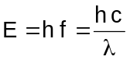 | 1
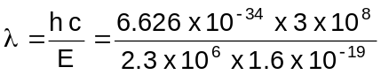  = 5.40 × 10⁻¹³ m | 1

Question 19(a)(ii)
spectrum
Description | Mark
X-rays (It is acceptable to have gamma rays). | 1

Question 19(b)
Using radiation
Description | Mark
Yes | 1
Short wavelength means it penetrates solids well | 1
More radiation would pass through a crack so highlighting its presence | 1

Question 19(c)(i)
Radius of circle
Description | Mark
KE = ½ m v² ⇒ 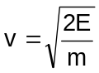 | 1
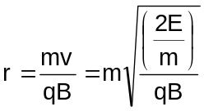 | 1
r = 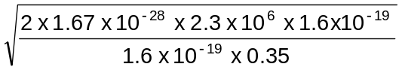  = 198 mm | 1

Question 19(c)(ii)
Radius change
Description | Mark
If kinetic energy increases then speed increases | 1
From the formula 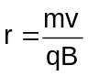, then radius would increase | 1

Question 20(a)
Maximum height and range
Description | Mark
v_{H} = 40 cos 60º v_{V} = 40 sin 60º | 1
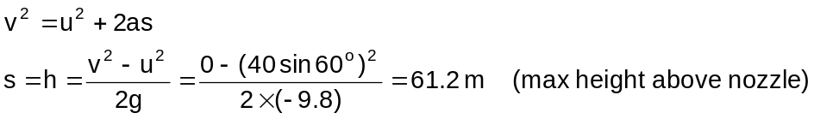 | 1
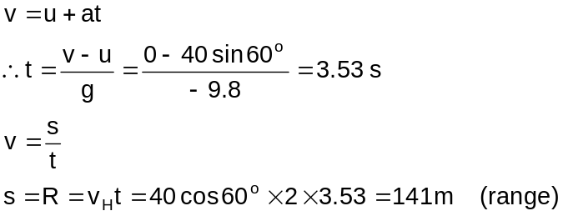 | 1

Question 20(b)
Helicopter height
Description | Mark
Horizontal: s_{H} = 150 m v_{H} = 22 m s⁻¹ 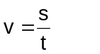 | 1
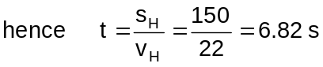 | 1
Vertical: 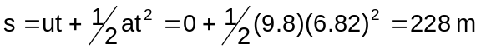(= minimum height) | 1

Question 20(c)(i)
Height and range from graph
Description | Mark
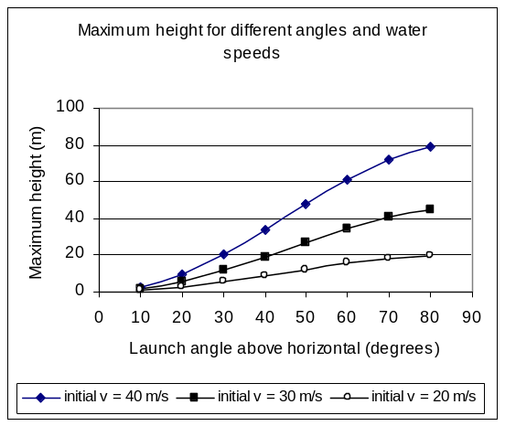 | 1
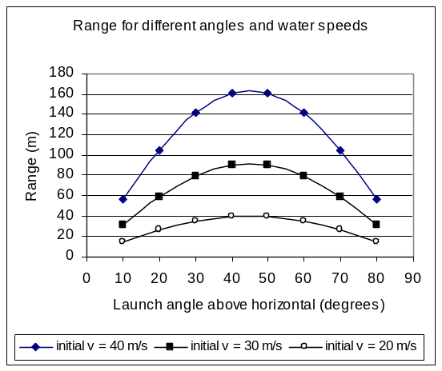 | 1

Question 20(c)(ii)
Angles and speed
Description | Mark
Best angle = 60° Best velocity = 30 m s⁻¹ | 1
Explanation may include any of the following:  Maximum height should be around 35 m  Launch speed = 20 m s⁻¹ won’t reach required height  Launch speed = 30 m s⁻¹ but angles ≤ 50° and ≥ 60° won’t reach required height  Launch speed = 40 m s⁻¹ at angle of 70-80° is possible but reaches too great a height | 1

Question 21(a)(i)
Distance travelled
Description | Mark
Distance = v.T | 1

Question 21(a)(ii)
Number of particles
Description | Mark
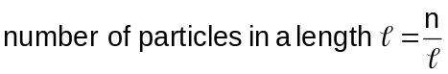 | 1
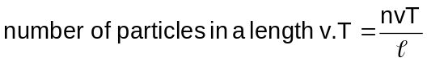 | 1

Question 21(b)
Current equivalence
Description | Mark
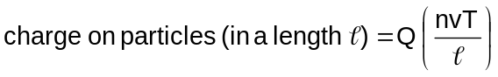 | 1
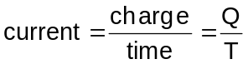 | 1
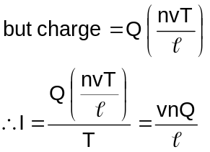 | 1

Question 21(c)(i)
Direction of electric force
Description | Mark
to the left, eg | 1

Question 21(c)(ii)
Particle path
Description | Mark
v  Observer  E  Path curves clockwise as shown | 1

Question 21(d)(i)
Magnetic field direction
Description | Mark
Out of the page or | 2
Into the page | 1

Question 21(d)(ii)
Magnetic force equivalence
Description | Mark
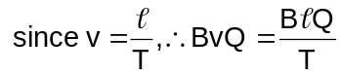 | 1
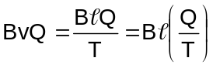 | 1
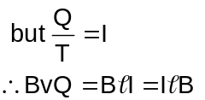 | 1
Section three: Comprehension

Question 22(a)
Resonant frequency of bubbles
Description | Mark
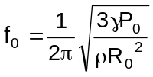 | 1
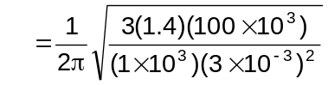 | 1
≈ 1100 Hz | 1

Question 22(b)(i)
Cavitation location
Description | Mark
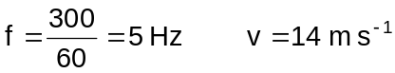 | 1
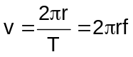 | 1
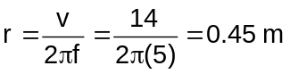  i.e. 0.45 m along blade from centre. | 1

Question 22(b)(ii)
Cavitation damage
Description | Mark
The tips of the blades or where water speed (relative to blade) is greatest | 1

Question 22(c)(i)
Snapping shrimp bubbles
Description | Mark
From figure 1: radius ≈ 3.5 mm | 1

Question 22(c)(ii)
Bubble collapse time
Description | Mark
From either figure: time ≈ 0.3 ms | 1

Question 23(a)
Photon momentum
Description | Mark
Photons have momentum | 1
change in momentum (on reflection) creates a force | 1
photon  Force  (1 mark if angles not approximately correct) | 2

Question 23(b)
Compton scattering
Description | Mark
Particle property | 1
Possible reasons are momentum is a property of particles, or collisions are characteristic of particles | 1

Question 23(c)
Momentum units
Description | Mark
Particle : p = m v = kg m s⁻¹ | 1
Photon : 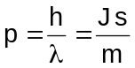 | 1
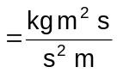= kg m s⁻¹ | 1

Question 23(d)(i)
Higher momentum
Description | Mark
X-ray photon has the larger momentum | 1
Reason : It has a smaller wavelength | 1

Question 23(d)(ii)
Momentum calculation
Description | Mark
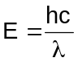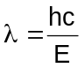 | 1
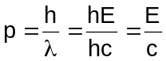 | 1
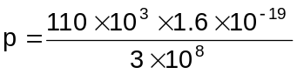= 5.87 × 10⁻²³ kg m s⁻¹ | 1

Question 23(d)(iii)
Scattering angle
Description | Mark
Needs to be scattered through 180° | 1
cos (180°) = -1 so change in wavelength is greatest | 1

Question 23(e)
Energy of scattered electron
Description | Mark
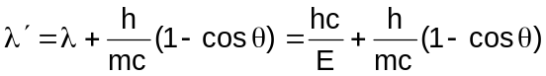  = 1.251 × 10⁻¹¹ m | 1
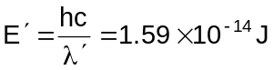= 99.2 keV = 99.2 keV | 1
Hence scattered electron energy is 19.8 keV or 3.17 x 10⁻¹⁵ J | 1

Overall - units
Description | Mark
Consistent, appropriate use of units in final answers (no more than two unit errors in entire paper) or | 2
Inconsistent or inappropriate use of units in final answers (three or four unit errors in entire paper) or | 1
Poor use of units in final answers (five or more unit errors in entire paper) | 0

Overall – significant digits
Description | Mark
Consistent, appropriate use of significant digits in final answers (no more than two SD errors in entire paper) or | 2
Inconsistent or inappropriate use of significant digits in final answers (three or four SD errors in entire paper) or | 1
Poor use of significant digits in final answers (five or more SD errors in entire paper) | 0
Physics Stage 3 exam

 | 3A |  |  |  | 3B
 | Working in physics | Motion and forces in a gravitational field | Electricity and magnetism |  | Working in physics | Particles, waves and quanta | Motion and forces in electric and magnetic fields
SECT 1
1 |  |  |  |  |  | Dpt 7
2 |  | Dpt 9
3 |  |  |  |  |  | Dpt 15
4 |  | Dpt 12
5 |  | Dpt 10
6 |  |  | Dpt 2, 3
7 |  |  | Dpt 8
8 |  |  |  |  |  | Dpt 1
9 |  |  | Dpt 9
10 |  | Dpt 3, 13
11 |  |  |  |  |  |  | Dpt 4
12 |  | Dpt 2, 3
13 |  | Dpt 2, 9
14 |  |  |  |  |  |  | Dpt 6
15 |  |  |  |  |  | Dpt 11
SECT 2
16 |  |  |  |  |  | Dpt 3, 4
17 |  |  |  |  |  | Dpt 9, 10, 16
18 |  |  | Dpt 8, 9 |  | X
19 |  |  |  |  |  | Dpt 6, 10, 16 | Dpt 4
20 | X | Dpt 1, 2, 5
21 |  | Dpt 5 | Dpt 5 |  |  |  | Dpt 3, 4, 6
SECT 3
22 |  |  |  |  | X
23 |  | Dpt 5 |  |  | X | Dpt 5, 6
overall
 | X |  |  |  | X

 | Sample physics exam stage 3 | (2008/18609)
 | design brief fit analysis
 |  | section 1 | section 1 | section 2 | section 2 | section 3 | section 3 | overall | total | total % | total allowed
 |  | items | marks | items | marks | items | marks | marks* | marks
15–20% | Working in Physics | nil | 0 | 20c | 4 | 22a, 22b(ii), 22c, 23c, 23d, 23e | 19 | 4 | 27 | 19.3 | 15-20%
20–25% | Motion and forces in a gravitational field | 2, 4, 5, 10, 12, 13 | 19 | 20a, 20b, 21a | 9 | 23a, 22b(i) | 7 |  | 35 | 25 | 20-25%
15-20% | Electricity and magnetism | 6, 7, 9 | 10 | 18a, 18b, 18c, 18d, | 13 |  |  |  | 23 | 16.4 | 15-20%
20–25% | Particles, waves and quanta | 1, 3, 8, 15 | 8 | 16a, 16b, 17a, 17b, 19a, 19b | 24 | 23b | 2 |  | 34 | 24.3 | 20-25%
15–20% | Motion and forces in electric and magnetic fields | 11, 14 | 6 | 19c, 21b, 21c, 21d, 21e, | 15 | - | - |  | 21 | 15 | 15-20%
 | totals | 13 items | 43 | 6 items | 65 | 2 items | 28 | 4 | 140 | 100
 | total % |  | 30.7 |  | 46.4 |  | 20 | 2.9
 | total allowed | 12-15 items | 25-35% | 6-8 items | 45-55% | 1-2 items | 15-25% | 2-3%

* ‘overall marks’ refers to an allocation for appropriate use of units and significant digits.

